

A PLASTIC RECYCLING MACHINE

Senior Project

by

Ibrahim Walid Alkayali, 51530414

Serge Bedwin Halabi, 51730413

Submitted to the School of Engineering of the

Lebanese International University

Tripoli, Lebanon

in partial fulfillment of the requirements for the degree of

Bachelor of Science in Mechanical Engineering

Spring 2019 - 2020

|  |  |  |
| --- | --- | --- |
| Approved By | | |
| Dr. Mikhael Tannous |  |  |
| Supervisor | Date | Signature |
| Dr. |  |  |
| Committee Member | Date | Signature |

Dedication

Our project is dedicated to the Lebanese environment. Also, we dedicate this project to the native industries, schools, and public areas (beaches, parks, malls, etc.). Moreover, our work is dedicated to the Lebanese public including our parents and relatives.

Acknowledgements

We would like to thank Dr. Mikhael Tannous for the unlimited guidance that he offered. Besides, we appreciate the university and all our doctors who supplied us with the needed information since the very beginning of our learning process.

Abstract

Lebanon was ranked 5th in the 2019 Pollution Index for Country, issued by Numbeo website which examined the pollution in countries worldwide [1]. The country scored 87.39% on the report coming ahead of bigger countries with a large number of populations such as Nigeria, Egypt, China, and others [1]. To reduce this dilemma, we will be researching recycling the core causes of pollution (plastics) and thus we will be developing PRM (Plastic Recycling Machine) that operates on recycling plastics. We will be monitoring a whole process that includes researching, scheming, calculating, designing, executing, and concluding the overall project.

The monitored process that we did will result in a low budget machine with high efficiency that will be illustrated on SolidWorks.

Table of Contents

Dedication ii

Acknowledgements iii

Abstract iv

Table of Contents v

List of Figures viii

List of Tables x

List of Symbols and Abbreviations xi

Chapter 1. Introduction 1

1.1. Overview 1

1.2. Problem statement 1

1.3. Objectives 2

Chapter 2. Literature Review 3

2.1. Introduction 3

2.2. History 5

2.3. Causes of plastic waste 11

2.4. Effects of plastic waste 12

2.5. Recycling plastics 15

2.6. Recycling machines 18

2.7. The need for plastic machines in Lebanon 21

2.8. Conclusion 22

Chapter 3. Design 23

3.1. Introduction 23

3.2. Description 24

3.3. Design calculation 26

3.3.1. Shredding mechanism 26

3.3.1.1. Blades: 26

3.3.1.2. Shafts: 29

3.3.2. Prime mover 31

3.3.2.1. Driving angular velocity 31

3.3.2.2. Power 31

3.3.2. Tnasmission 34

3.3.2.1. The gearbox 34

3.3.2.2. Pulley and belt systems 34

3.3.2.3. Gears 41

3.4. Conclusion 43

Chapter 4. Prototype construction 44

4.1. Level 2 Section 46

Chapter 5. Non-Technical Aspects 47

5.1. Introduction 47

5.2. Economical/Financial 47

5.3. Project Management 47

5.4. Ethical and Social 48

5.5. Environmental and Sustainability 48

5.6. Standards 48

Chapter 6. Results 50

6.1. Level 2 Section 50

Chapter 7. Conclusion 51

Appendix A. Title of the App A 52

A.1. Level 2 in Appendix, Apply Heading 6 52

A.1.1. Level 3 in Appendix, Apply Heading 7 52

A.1.1.1. Level 4 in Appendix, apply Heading 8 52

A.1.2. Equations in Appendix A 52

Appendix B. Title of the App B 54

B.1. Level 2 Section, Apply Heading 2 54

B.2. For the References: 54

B.2.1. To Cite a New Reference 55

B.2.2. Equations in Appendix B 55

List of Figures

Figure 2.1. Trash disposal to sea [3]. 3

Figure 2.2. Plastic waste [4]. 4

Figure 2.3. Primitive way to start a fire using wood [5]. 6

Figure 2.4. Rubbing stones together to make fire [6]. 6

Figure 2.5. Wheels used to transport goods [8]. 7

Figure 2.6. PET plastic bottle [11]. 9

Figure 2.7. PVC pipes [11]. 10

Figure 2.8. Nylon rope [11]. 10

Figure 2.9. Microplastics [12]. 13

Figure 2.10. Microplastics ingested by fish [13]. 13

Figure 2.11. XNRONG crushing and washing line [19]. 19

Figure 2.12. Recycling process [19]. 19

Figure 2.13. GE Series Europe Type Fine Shredder [20]. 20

Figure 2.14. JC-ECOTRIM Series Recycled Pelletizing Machine [21]. 20

Figure 3.1. The Shredding machine with all parts. 25

Figure ‎3.2. Dimensions of one blade (SolidWorks). 26

Figure ‎3.3. Forces exerted on the blade’s area [23]. 27

Figure ‎3.4. Torque generated by one blade. 28

Figure ‎3.5. Torques generated by the blades on the shafts. 29

Figure ‎3.6. Power supplied from the motor to the shredding chamber. 32

Figure ‎3.7. Selected motor [25]. 33

Figure 3.8. Industrial V-Belt selection chart. 35

Figure 3.9. Commercially available pulleys (in). 36

Figure 3.10. Commercially available V-Belt length (in). 39

Figure 3.11. Spur Gears 41

Figure 3.12. Spur gears configuration parameters. 42

Figure 4.1. First figure in chapter IV. 44

Figure A.1. First figure in appendix A. 50

Figure B.1. First figure in appendix B. 52

List of Tables

Table A.1. First table in Appendix A 12

Table B.1. First Table in Appendix B. 14

List of Symbols and Abbreviations

|  |  |
| --- | --- |
| Symbol or Abbreviation | Description |
| PRM | Plastic Recycling Machine |
| PETE/PET | Polyethylene Terephthalate |
| LDPE | Low density Polyethylene |
| HDPE | High density Polyethylene |
| PVC | Polyvinyl Chloride |
| PP | Polypropylene |
| F | Force: An interaction that causes an affected body to be pushed or pulled in a certain direction (N) |
| T | Torque: How much force is required to make a body rotates about its own axis (N.m) |
| W | Angular speed: is the rate at which an object changes its angle, in a given time period (rad/s) |
| P | Power: refers to the rate at which work can be done (W) |

# Introduction

## Overview

The world has been facing a devastating dilemma which is pollution since human life started to get more sophisticated. Among them, plastic pollution is considered to be the worst invisible enemy to our green environment which has figuratively and literally considerable gray effects on the public. Consequently, we are trying to reduce these effects by the Plastic Recycling machine (PRM) in Lebanon at least. This project permits the recycling of plastics so that different parties can reuse it for different purposes.

## Problem statement

Lebanon has always been known to be one of the most beautiful countries ever; however, pollution caused mainly by plastics affected the public health and endangered nature. At some specific areas like beaches, people swim and party leaving a lot of plastic bottles behind. Likewise, in the mountains, people practice hunting and camping which deface the natural picture of the valley from green to junk because of the hunting rifle bullets and plastic products. This reckless mankind's behavior raises numerous problems. One issue is the growth of soil pollution that may cause a variety of health problems starting with headaches, nausea, fatigue, skin rash, eye irritation and potentially resulting in more serious conditions like neuromuscular blockage, kidney, and liver damage and various forms of cancer [2]. Another concern that pops up is rationally reducing tourism rates in Lebanon affecting the economy of the country somehow. Furthermore, the Lebanese government unwisely imports plastic material for manufacturing purposes, and this is a real problem that weakens the economy of the country.

## Objectives

The main objective of our project is to reduce pollutants and consequently reducing plastic pollution rates in Lebanon by theorizing then manufacturing our PRM. We will discuss the different aspects needed for our design. We are looking forward to a certain design that will have a small size compared to other designs that already exist in the market and this what makes it a greater advantage over other designs. Also, it will have high performance relative to its size. And finally, PRM will work properly and effortlessly by users when they follow its easy instructions.

This document is divided into seven chapters including this one. Chapter two talks about the literature review. Chapter three is dedicated to the project design. Chapters four and five discuss non-technical aspects (SolidWorks) and results and conclusions respectively. At last, we will represent the project of the PRM then will simulate it on SolidWorks software.

# Literature Review

## Introduction

Pollution is a universal dilemma that has been facing the world ever since humans started to evolve. It is considered to be an invisible virus to modern societies and has a lot of classes like water pollution, air pollution, noise pollution, light pollution, and soil pollution.

Water pollution is the contamination of lakes, rivers, oceans, aquifers, and groundwater usually as a result of human activities. Water pollution results when contaminants are introduced into the natural environment. For instance, trash disposals such as plastic bags, fishing line, and other materials may accumulate in the water (as shown in Figure 2.1) and lead to the premature death of animals that get tangled within the garbage.

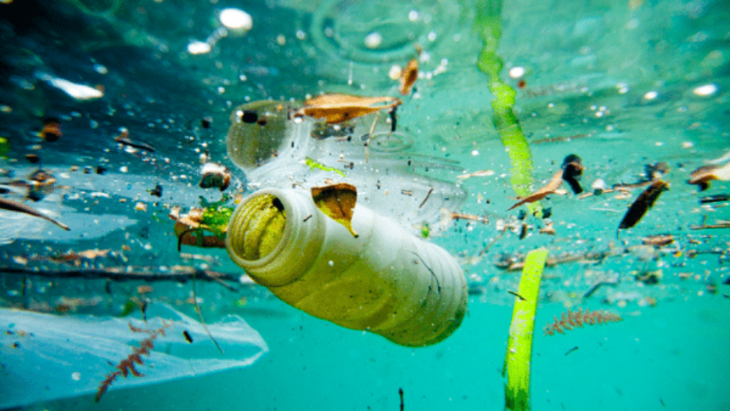

Figure 2.1. Trash disposal to sea [3].

Soil pollution is another type of contamination that is considered to be fatal to humankind. For this reason, our concern here will be about plastic waste and the consequences that lead to soil pollution. Plastic junk like those in Figure 2.2 causes harms to humans, animals, and plants since it can take hundreds or even thousands of years for plastic to break down so the environmental damage is long-lasting. It affects all organisms in the food chain from tiny species like plankton through to whales. In addition to plastic waste, it is important to mention the discarding of chemicals into the land that happens to venom our agriculture and represent a very real risk to humankind. This is mainly caused by the influence of our industries that do not tolerate the progressive attitude towards nature.

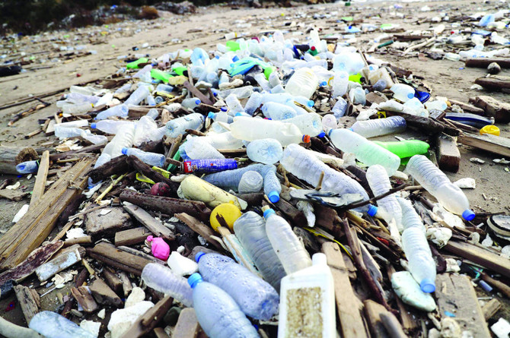

Figure 2.2. Plastic waste [4].

Moreover, air, light, and noise types of pollution are also measured to be hazardous to the world. Each sort of contamination has huge effects on our modern societies including plastic pollution which is our major concern in Lebanon. These impacts of plastic pollution can be categorized into different forms.

First, plastic pollution affects the health of all creatures including us, where humans intend to get rid of plastic waste in several ways. One way is burning the plastic leftovers which lead to air pollution due to the release of poisonous chemicals. Hence, the polluted air when inhaled by humans and animals affects their health and causes respiratory problems. Another way is dumping the garbage into the soil resulting in entanglement and ingestion.

Second, plastic pollution endangers the economy of Lebanon lowering the tourism rates as the plastic junk defaces the natural pictures.

As all these negative aspects of plastic pollution pop up, a major question must be considered regarding finding a solution to this problem. Would Lebanon consider recycling the plastic waste as a good solution? Would it support the manufacturing of plastic recycling machines so that the pollution rates decrease?

## History

For millions of years all humans, early and modern alike, had to survive somehow. They spent a large part of each day gathering plants and hunting or scavenging animals. Then, within just the past 12,000 years, our species made the transition to producing food and changing our surroundings. We have been so successful that we have inadvertently created a turning point in the history of life on Earth.

Back to previous ages, humankind used primitive methods to survive, so they used traditional resources to be able to maintain their basic needs. For example, they crafted wooden weapons such as native bows, trapezoidal micro blades, and axes to

both hunt and defend themselves against animals and predators. Then, humans discovered fire, they knew two basic methods to start a fire. The first method was the friction between wooden materials as shown in Figure 2.3.

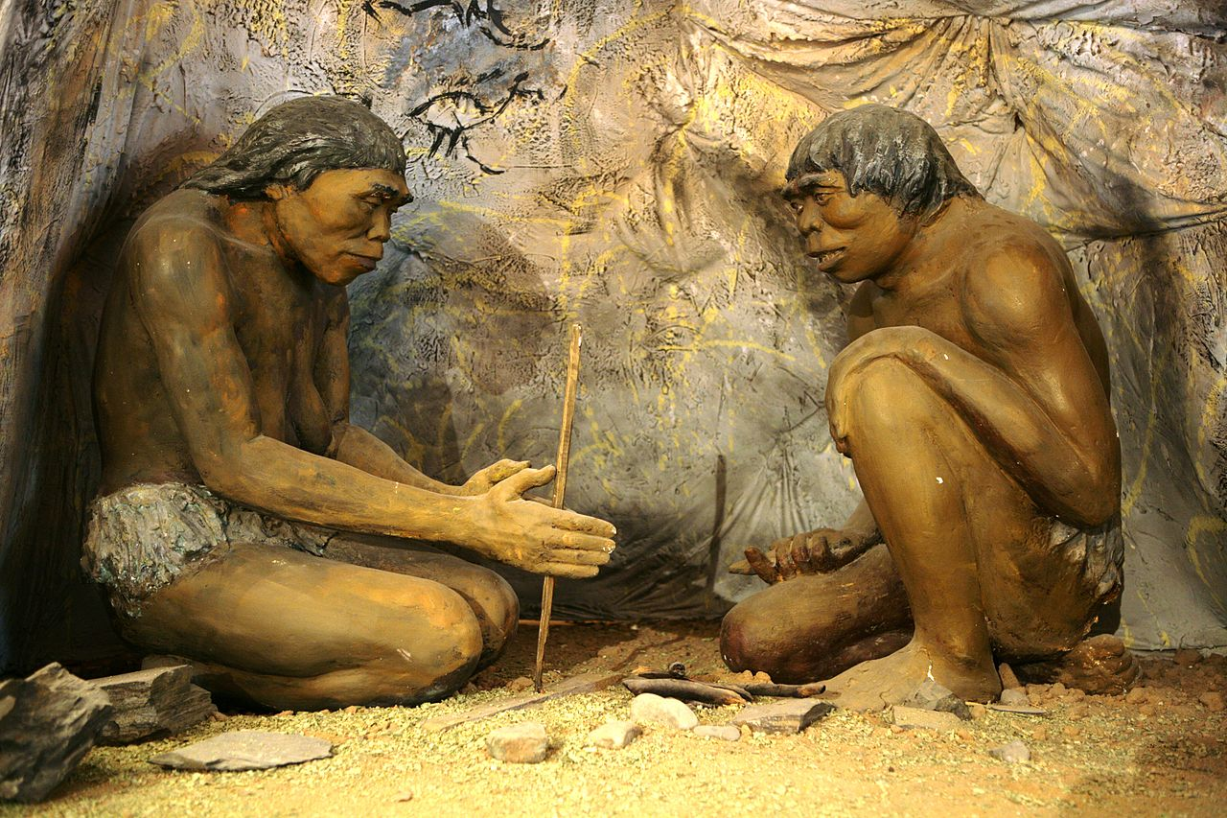

Figure 2.3. Primitive way to start a fire using wood [5].

The second method was the spark resulted from other materials like stones as shown in Figure 2.4. Fire supplied early humans with protection and warmth besides cooking.



Figure 2.4. Rubbing stones together to make fire [6].

As tribes started to grow, they realized that they need to increase food production to maintain an easier life so that they continue to survive. For this specific reason, humans found farming and agriculture, thus their diet changed accordingly. Furthermore, for the very same purpose, the first invention of humankind was achieved which was the simple wooden wheel since 3500 BC (see Figure 2.5) [7].

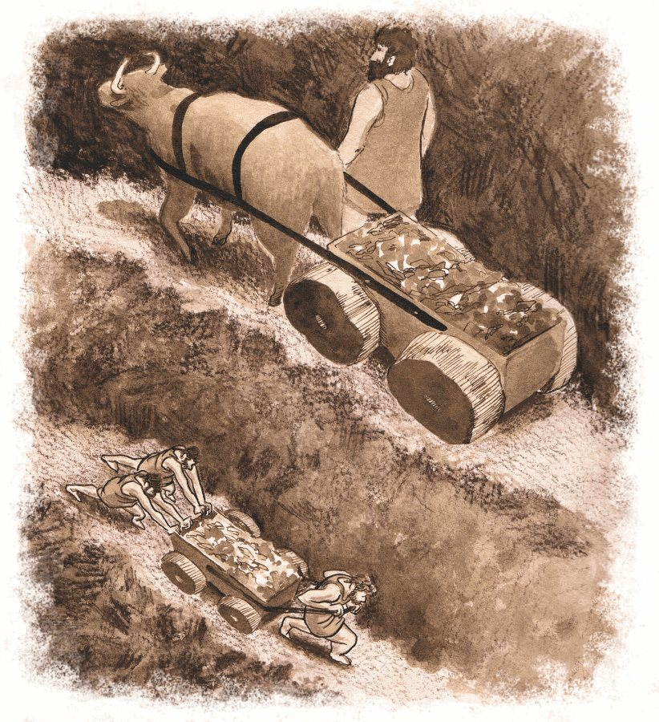

Figure 2.5. Wheels used to transport goods [8].

This invention was used in several ways for one purpose which is simplifying human efforts and facilitating life. For instance, relatively rapid transportation, which was crucial to early humans, was the first use of wheels but combined with carts and chariots allowing them to carry goods, to travel, and to make new encounters.

Later on, as a human’s thoughts developed, they started to work on different inventions related to the previous ones. One invention demands another. For instance, after the wheel invention that allowed transportation, humans needed to know directions so that they invented the compass since 206 BC [7]. They also needed to know the time as they travel in specific directions, so they invented the calendar since 45 BC and the clock since 725 AD [7].

As the human’s necessities developed through time, humans started to be more innovative and artistic, they found themselves obliged to use different materials than wood and stone. So, they jumped to more advanced materials like metal, glass, and cotton. Analogously, research for a better material arisen after humans realized the importance of using a light, flexible, and durable material for numerous purposes and nearly in all continuously developing fields.

Afterward, humans created the very first plastic by Alexander Parkes in 1862 [9]. Besides the introduction of machines and factories in the latter half of the 18th century of the industrial revolution, the discovery of plastics was as well revolutionary and life-changing. As machines took control over the world easily, plastics conquered the latter rapidly [10]. Needless to say, for the first time human manufacturing was not constrained by the limits of nature. This very first plastic, called Parkesine, was an organic material derived from cellulose that, once heated, could be molded and retained its shape when cooled [9]. Enhancement after another, from cellulose, came to the use of a new product called formaldehyde, after that, it evolved to casein plastics then to formaldehyde resins [9]. However, in 1907, Leo Hendrik Baekeland upgraded phenol-formaldehyde reaction techniques and invented the first fully synthetic resin to become commercially successful under the trade name Bakelite [9]. This latter was not only a good insulator; it was also durable, heat resistant, and, unlike celluloid, ideally suited for mechanical mass production. Likewise, improvements grew even better to introduce new-formed multiuse products that diverged into families and categories. The main plastic products in this vast space of plastics can be stated as follow: Polyethylene Terephthalate (PETE or PET since 1941), Polyethylene (low-density LDPE since 1935, high-density HDPE since 1951), Polyvinyl Chloride (PVC since 1872), Polypropylene (PP since 1951), Nylon (since 1939) [11].

Humans, unambiguously had a long journey discovering these plastic types. However, these products have been definitely worthy, and that’s because they resist environmental degradation over time, they are generally safe for human beings, they are economical and widely available and they are produced with a diverged variety of material properties that allow adaptation to many different applications which depend on the types of plastic. For instance, PET is the most commonly manufactured plastic in the world. It has extremely effective moisture; it is also shatterproof. This product is used mainly as a fiber and for bottling or packaging. Figure 2.6 represents a plastic bottle made of PET.

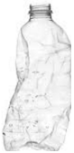

Figure 2.6. PET plastic bottle [11].

Another essential plastic-type, Polyvinyl Chloride (PVC), it is probably most well-known for its use in residential and commercial property construction applications. Different types of PVC are used for plumbing, and insulation of electrical wires through pipes (see Figure 2.7). PVC products could be brittle, rigid, and strong.

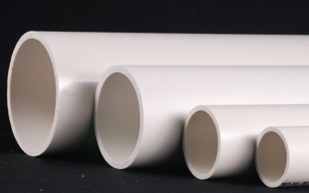

Figure 2.7. PVC pipes [11].

Besides the two types of plastics stated above, Nylon is another crucial type of plastics that is everywhere. It is used for a variety of applications to include clothing, reinforcement in rubber material like car tires, for use as a rope (as in Figure 2.8) or thread and several injection molded parts for vehicles, planes and mechanical equipment. It is usually used as a substitute for low strength metals in applications like car engines because of its high strength (relative to other plastics), high temperature resilience and high chemical compatibility.



Figure 2.8. Nylon rope [11].

Thus, this is briefly the use of some types of plastics that apparently took an important place in our daily lives. Nonetheless, humans, and since the beginning, always regard themselves to be in control of nearly everything their mind could conceive and grasp. Yet, thinking blindly that they have the upper hand over technology and inventions, and they are cursed with knowledge and wisdom, for this very reason, quite a few misapprehending and mispredicting of some of their discoveries, such as plastics, have put them one step behind, and have led them to face even bigger problems and challenges than the ones that they solved before. Perhaps, problems have beneficial undesirable results that could uncloud the vision of humans and let them free. By conceiving results, humans can find answers to the right asked questions. How did pollution start? How can it be examined? And how can it be reduced before it tears down mother nature?

## Causes of plastic waste

As the world’s population keeps growing up, so does the mass of garbage that humans produce. This garbage includes a great percentage of plastic waste such as plastic bottles and bags; however, the accumulation of these products has led to increasing the volume of plastic pollution around the world. Some countries like Lebanon cannot control the fast spread of plastic pollution because of the lack of sophisticated facilities that may seriously slow it down. Thus we need to analyze and understand the different core causes that lead to plastic pollution.

First, plastic products are everywhere even on items people do not expect it to be. For instance, water bottles are handed in almost every place as well as plastic bags are widely used in almost every store. Second, plastic products are less expensive making it one of the most widely available and overused items in Lebanon today. Unfortunately, these products are mainly made to be used only once, so accordingly, people throw it away leading to increase plastic pollution. Third, fishing materials like fishing nets that are used for certain large-scale trolling operations are usually made of plastic. Fish is one of the main meals on the Lebanese people’s diet list, thus commercial fishing is an economic necessity for Lebanon; however, the fishing nets left to remain wherever they fall and get lost. Finally, in order to get rid of plastic trash, regulators and Lebanese governors have two methods. It either be burnt or disposed on landfills. However, burning leads to air pollution due to the release of toxic gases that causes respiratory problems to humans, animals, and plants. Correspondingly, disposing of plastics in the land releases toxins in the area and may reach underground water because plastics are meant to last and take hundreds to thousands of years to decompose.

## Effects of plastic waste

It seems rather obvious that this amount of a material that isn’t meant to break down can wreak havoc on natural environments, leading to long-term issues for plants, animals, and people. Some of the major long-term effects of plastic pollution are the following.

First, as previously mentioned, it upsets the food chain because plastic waste comes in different shapes and sizes from microplastics to bottles, bags, and etc.

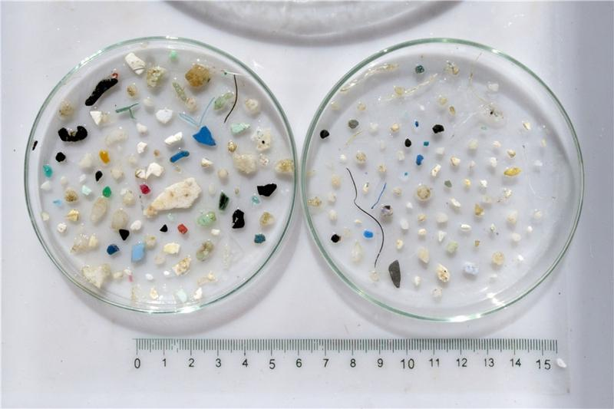

Figure 2.9. Microplastics [12].

Microplastics (like those present in Figure 2.9) when consumed by the tiniest organisms such as plankton, make it poisonous and this causes problems to a larger animal that depends on them for food. As this poison goes further on each step of the food chain it will eventually reach humans as they eat fish that has plastic in it as clearly shown in Figure 2.10. This could really affect human’s health and pose a great danger to the aquatic animals.

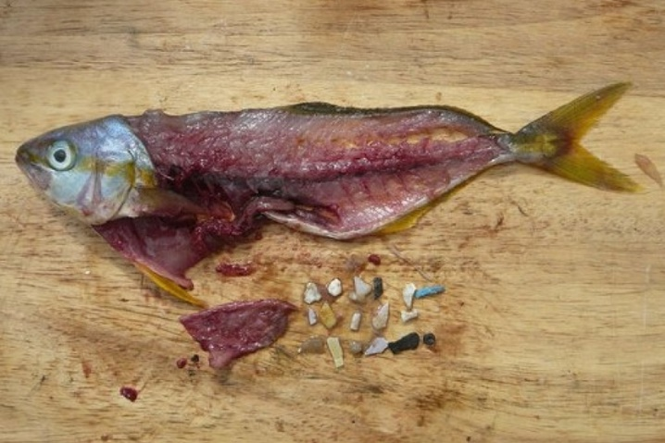

Figure 2.10. Microplastics ingested by fish [13].

Second, plastic pollution certainly leads to land pollution, underground water pollution, and air pollution. When plastic waste is dumped in landfills it interacts with water and forms hazardous chemicals that by its role lead to several illneseses to humankind such as fatigue, eye irritation, skin rash, and potentially resulting in more perilous conditions like different forms of cancer [2]. Moreover, when these chemicals seep underground they degrade the water’s quality which consequently leads to underground water pollution. Nevertheless, when plastic waste is carelessly burned in the open air, it leads to air pollution due to the release of poisonous chemicals such as Dioxins, Furans, Mercury, and Polychlorinated Biphenyls into the atmosphere [14]. Furthermore, burning Poly Vinyl Chloride liberates hazardous halogens, the impact of which is climate change that threatens the whole planet. The toxic substances thus released are posing a threat to vegetation, human and animal health, and the environment as a whole. Polystyrene is harmful to the Central Nervous System. The hazardous brominated compounds act as carcinogens and mutagens. Dioxins settle on the crops and in our waterways where they eventually enter into our food and hence the body system.

Third, it costs millions of dollars each year to clean affected areas after exposure, not to mention the loss of life to plants, animals, and people. As land becomes more valuable, just finding a place to put garbage is becoming a problem in many parts of the world and especially in countries like Lebanon.

Forth, excess pollution leads to decreased tourism in affected areas, significantly impacting those economies.

## 2.5. Recycling plastics

As listed previously, the influence of plastic waste on all living creatures is unquestionably deadly and destructive. And implementing the traditional stated ways to get rid of garbage only makes it worse. But from the very beginning, human’s thoughts were to repair then reuse any manufactured products. Furthermore, they knew that these methods are absolutely unhealthy and there must be another way to have the job done properly. Therefore, and as humans continued to develop their thoughts and to upgrade machines all around the world, the manufacture of the first plastic recycling machine took place in America, in 1972 [15]. Plastic recycling is the process of recovering different types of plastic material in order to reprocess them into varied other products, unlike their original form. It is the modern beneficial way that persistently substituted dumping and burning methods due to its advantageous outcomes; it properly gets rid of plastic junk, reducing pollutants and increasing tourism outcomes, it allows us to reuse plastic recyclables, decreasing plastic’s imports.

While plastics have been recycled since 1972, the quantities that are recycled vary geographically, according to plastic-type and application. Plastic materials can be recycled in a variety of ways too. For instance, the ease of recycling varies as well among polymer type and package design. For example, rigid containers consisting of a single polymer are simpler and more economical to recycle than multi-layer and multi-component packages [16].

Another example, unlike thermoplastics, including PET, PE, and PP that all have high potential to be mechanically recycled, thermosetting polymers such as unsaturated polyester or epoxy resin cannot be mechanically recycled [16]. Thus, it is obvious that: first, not all plastic types are recyclable. Second, there are many challenges in producing recyclables from plastic wastes. Third, for this action to be done, some essential criteria must be respected thoroughly. The whole method could be simplified briefly as follows:

*Step one*: Collecting

The primary step in the recycling process is always collecting the plastic material that is to be recycled. Plastic waste should be disposed of in the correct places, thus government should place announcements about local collection points that should be easy for the public to access. The Lebanese government should supply in specific trash bins specialized for plastic waste making it easy and convenient for people to correctly dispose of plastic waste is paramount in promoting recycling.

*Step two*: Storing

Plastics are stored in a few different ways, such as the material plastic is made with, how it is made and its color. This is essential because diverse types of plastics must be processed in different ways. Incorrectly processing the wrong type of plastic at some certain facility will not work, however, this reduces the efficiency of the whole process and require the entire batch to be sent back again for restoring.

*Step three*: Washing

As we wash clothes, plates, vegetables, and many other things, plastics must be washed before they are further treated in order to remove impurities (all other things that are not made from plastic). These non-plastic materials can cause the final product to have poor structural integrity when recycled with the plastics.

*Step four*: Resizing

This step requires shredding and cutting plastics into small particles making its surface area bigger and thus making it easier to reshape, process, and transport if needed. Moreover, this gives an additional last opportunity for specific facilities to remove non-plastic waste. This is mainly done effortlessly using metal detectors or magnets that will help remove any leftover metal in the mixture.

*Step five*: Identification and separation of plastics

During this step, plastic particles are tested to determine their quality and class. They are tested to determine four different categories which are, its density, air classification, melting point, and color. This is done firstly by placing the plastic particles in a tank of water. Particles that float are less dense than water; however, particles that sink are consequently more dense than water. Secondly, plastic particles will be dropped into a small wind tunnel separating smaller pieces from the bigger ones in which the former will fly higher up the tunnel while the latter ones will remain lower. Finally after analyzing the plastic samples, they will be separated by their color and their melting points.

*Final Step:* Compounding

In this last step, small particles of plastic are smashed and melted together to form plastic pellets. The latter can be used in the production of plastic products [16].

Indeed, one of the important challenges for producing recyclables is that most different plastic types are not compatible with each other because of inherent immiscibility at the molecular level, and differences in processing requirements at a macro-scale. For example, a small number of PVC contaminants present in a PET recycle stream will degrade the recycled PET resin owing to the evolution of hydrochloric acid gas from the PVC at a higher temperature required to melt and reprocess PET. Conversely, PET in a PVC recycle stream will form solid lumps of undispersed crystalline PET, which significantly reduces the value of the recycled material [16].

Besides the above-written criteria, plastic recycling processes take into consideration the melting point, Young’s modulus, color, and other related plastic’s properties. For instance, another challenge that although black plastic is recyclable but often ends up in landfills as waste sorting systems can’t recognize black pigments [17].

As we conceived, processes and experimental inputs could vary according to the recyclable material’s aspects and situation.

## 2.6. Recycling machines

After some brainstorming, we had several random ideas that lead to the creation of concepts regarding our design of the machine. We conducted a list of potential design concepts that have both: advantages and disadvantages. However, as engineers do, we analyzed and investigated each concept to select the best one to represent our final project design. In general, factors like the design material (type and property), its cost versus quality, its shape, its size, its power system, etc. certainly affect in choosing the best concept. For example, in the market there exist several types of plastic recycling machines such as plastic granulating recycling line, plastic regrinding and washing line, plastic crusher and shredder, and a lot more [18].

Inconvenience, one design for recycling PET bottles that already exists in the world’s market is XINRONG: PET Bottle Washing Line (illustrated in Figure 2.11).

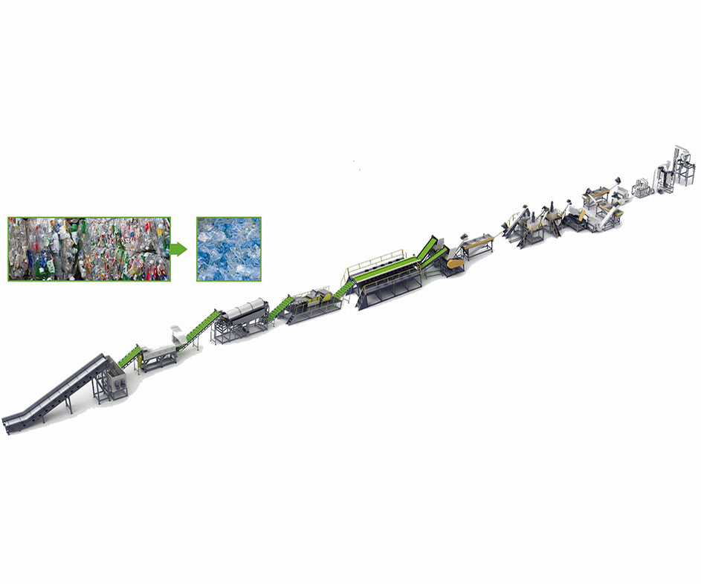

Figure 2.11. XNRONG crushing and washing line [19].

This machine applies two basic mechanisms: crushing and washing the PET bottles’ waste. The process of PET bottle recycling can be simplified as illustrated in Figure 2.12 starting from bottle conveying and then jumping through to crushing then washing and finally until reaching bottle packaging.

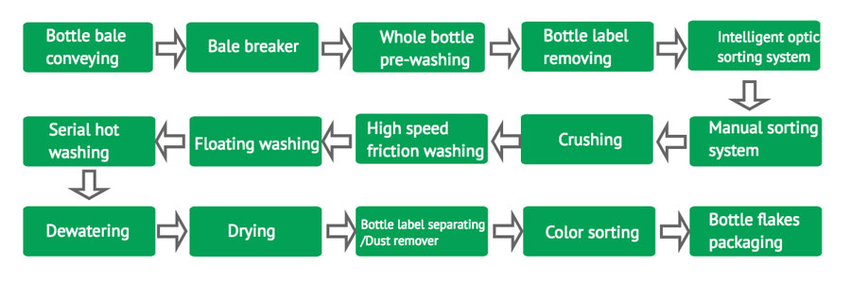

Figure 2.12. Recycling process [19].

Another design machine is the “GE Series Europe Type Fine Shredder” (see Figure 2.13). It adopts a single-shaft "double motor plus double reducer" drive design to provide large shearing force and ensure high shredding output. Usually used in the fine shredding of solid waste such as recyclable plastics of whatever type. It is widely used for plastic recycling in addition to garbage treatment, resource generation, and other fields. It has the characteristics of small discharging granularity, replaceable screen, wide material applicability, and high efficiency. The machine weight and output power range from 10 to 26 (t) and 75 to 400 (KW) respectively [20].

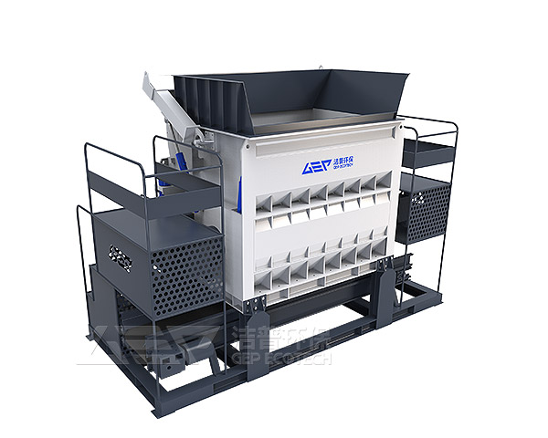

Figure 2.13. GE Series Europe Type Fine Shredder [20].

One more interesting design machine (illustrated in Figure 2.14) specialized to end the process of recycling is Recycled Pelletizing Machine (JC-ECOTRIM Series).

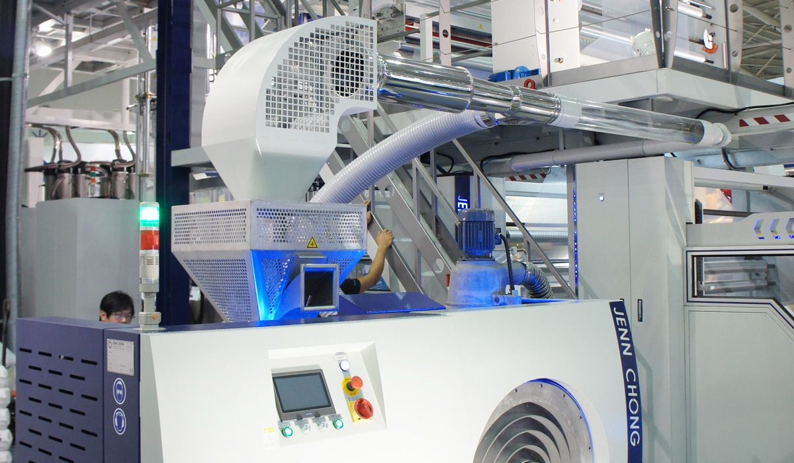

Figure 2.14. JC-ECOTRIM Series Recycled Pelletizing Machine [21].

The JC-ECOTRIM’s process starts from edge trim feeding, plasticizing, pelletizing, cooling, and reclaim, all in one complete procedure [21].

## 2.7. The need for plastic machines in Lebanon

As stated thoroughly earlier, Lebanon has been facing a disastrous situation regarding plastic waste and all its consequences [1]. We figured out that Lebanon desperately needs recycling, but unfortunately, our country cannot afford massive machines, such as the ones mentioned previously, as they are not cost-effective in many ways; initial cost, maintenance, factory upgrades that need to be made and attaining trucks to haul massive recycled materials.

However, for this reason, we decided to adopt a part of the recycling process that involves crushing and shredding of mainly PET bottles. This could be characterized by a plastic shredding machine that has numerous advantages. First, it is cost-effective due to its small size, thus it demands less power. Second, the machine minimizes the efforts of collecting plastic waste because it will be placed in public areas such as parks, universities and schools, city centers, airports, and railway stations, supermarkets, and commercial spaces. Third, and most importantly, it is an innovative solution for collecting empty bottles and increasing recycling rates as it encourages people to recycle with a reward system. Needless to say, the machine is environmentally friendly as it has low emissions.

## 2.8. Conclusion

The previous pages of the report sufficiently made it clear that our environment in Lebanon is persistently shattered mainly by plastic wastes. The report introduced and discussed several sides of the problem including its causes, effects, and ways to resolve it.

Recall, the main objective of our project is to minimize plastic pollution rates in Lebanon by theorizing then manufacturing our PRM that will have serious advantages over other recycling machines resulting in a promising outcome.

# Design

## Introduction

As we stated before, there exists a variety of plastic recycling machines (see section 2.5). Each sort works for a specific purpose; washing, crushing, shredding, or pelletizing. As we are concerned about the shredding part of the recycling process, we researched different types of shredding machines that are listed below:

* Chippers work on shredding materials such as leaves, small branches, and twigs into chip or flake from by maintaining high-speed rotary knives. These shredders can be automatically or manually fed and may employ single or multiple stage shredding machines.
* Granulators like chippers, employ chipping to transform recyclables into fine particles. However, they use stator knives and rotating blades instead of rotary knives to achieve the task. Grinders typically use abrasion to reduce materials into granular form. Regularly, abrasion is combined with compression to attain greater shredding results.
* Hammermills use basic force to shatter and pulverize materials. The most common configuration in hammermills is a gravity-fed chamber containing a rotary drum that has swiveling hammers mounted on it.
* Shear shredders use rotary blades to cut desired materials, and most importantly PET bottles [22].

Comparing all the functions of shredders we came out to choose to design a shear shredder machine because it perfectly fits our recycling procedure for PET bottles.

## Description

The main parts of our PRM design can be the following:

1. Frame, which is often a structural system that supports other components of the machine such as the motor [23], the pulley and belt systems, and the shredding chamber. Since we tend to place our machine in public places, we should consider choosing small dimensions of frame support, shredding chamber, and the feed hopper.
2. Shredding mechanism design mainly consists of: first, blade calculation; dimensions of blades, number of blades on the shaft, the force exerted by the blades on the plastic bottles, the torque required to shred the plastic, and material needed to avoid failure. Second, shaft dimensions, the distance required to calculate the torque, material needed to avoid fracture.
3. Prime mover; it consists of the motor whose only role is to supply the required power for the system to work properly. Power, torque, velocity, and efficiency are as well needed to be included in the calculation.
4. Transmission; since the motor’s output power results from high velocity and low torque, both pulley and belt system and gears system are needed to transmit a higher torque demanded the shafts and the blades to perform the shredding process.

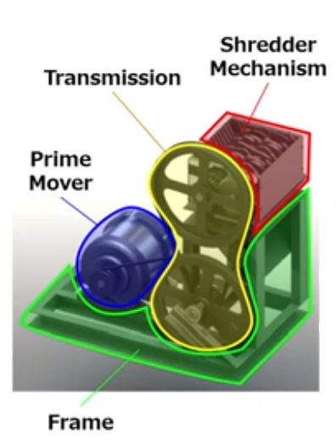

Figure 3.1. The Shredding machine with all parts.

Figure 3.1 shows all parts that we just talked about in the preceding paragraph. We will work on each part and calculate its required parameters separately.

## Design calculation

For convenience, the design calculation will be split into four parts that have been discussed in the previous section. These parts are all combined to form the system that will perform on the PET bottles to transform them into small parts under the action of shredding.

## 3.3.1. Shredding mechanism

Shredding mechanism is the most significant member of the whole process, since it actually fulfills the aim of the machine itself. All other elements rely on it in order to have the right conditions to operate properly. It will be subdivided into two parts: blades, and shafts.

#### Blades:

First, the dimensions of the blades are illustrated in Figure ‎3.1. This allows us to calculate the actual area where the force coming from the bottles to be applied. This actual area will be calculated according to equation 3.1.

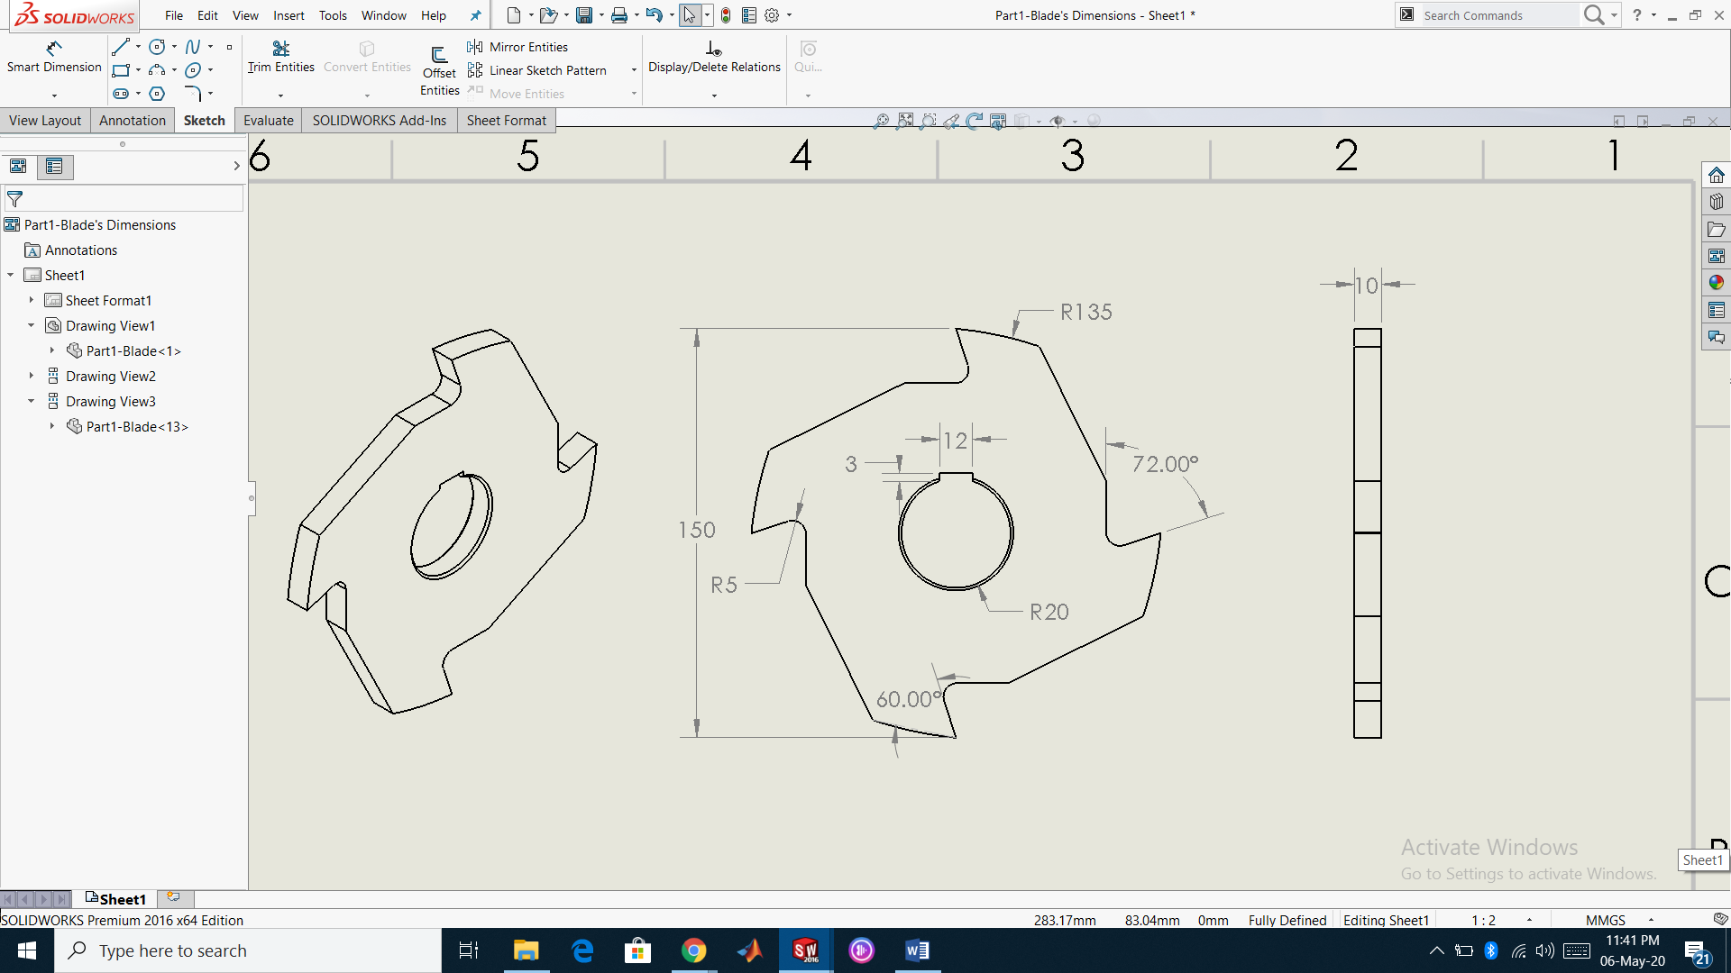

Figure ‎3.2. Dimensions of one blade (SolidWorks).

$A_{blade edge}=A_{geometric}×0.7\%$ (3.1)

Where:

$A_{blade edge}$: is the actual area where the force is applied partially (0.7%) on one sharp edge of the blade (${mm}^{2}$).

$A_{geometric}$: is the geometrical area computed on SolidWorks (141.7 ${mm}^{2}$).  
Thus:

$$A_{blade edge}=141.7×0.7\%= 1 {mm}^{2}$$

Second, to calculate the forces applied on one blade by PET bottles as illustrated in Figure ‎3.2, the below equation is used.

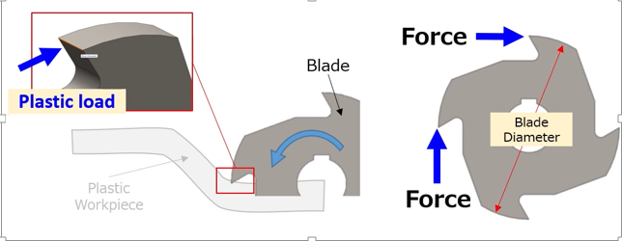

Figure ‎3.3. Forces exerted on the blade’s area [24].

$F=σ_{u-PET}×A_{blade edge}$ (3.2)

Where:

$F$: is the force exerted on one blade (N).

$σ_{u-PET}$: is the ultimate stress of the PET material (40MPa) [25].

Thus:

$$F=40×1{ mm}^{2}=40 N$$

Third, the torque exerted by one blade on the plastic material can be shown in Figure ‎3.3, and is calculated using the below equation.

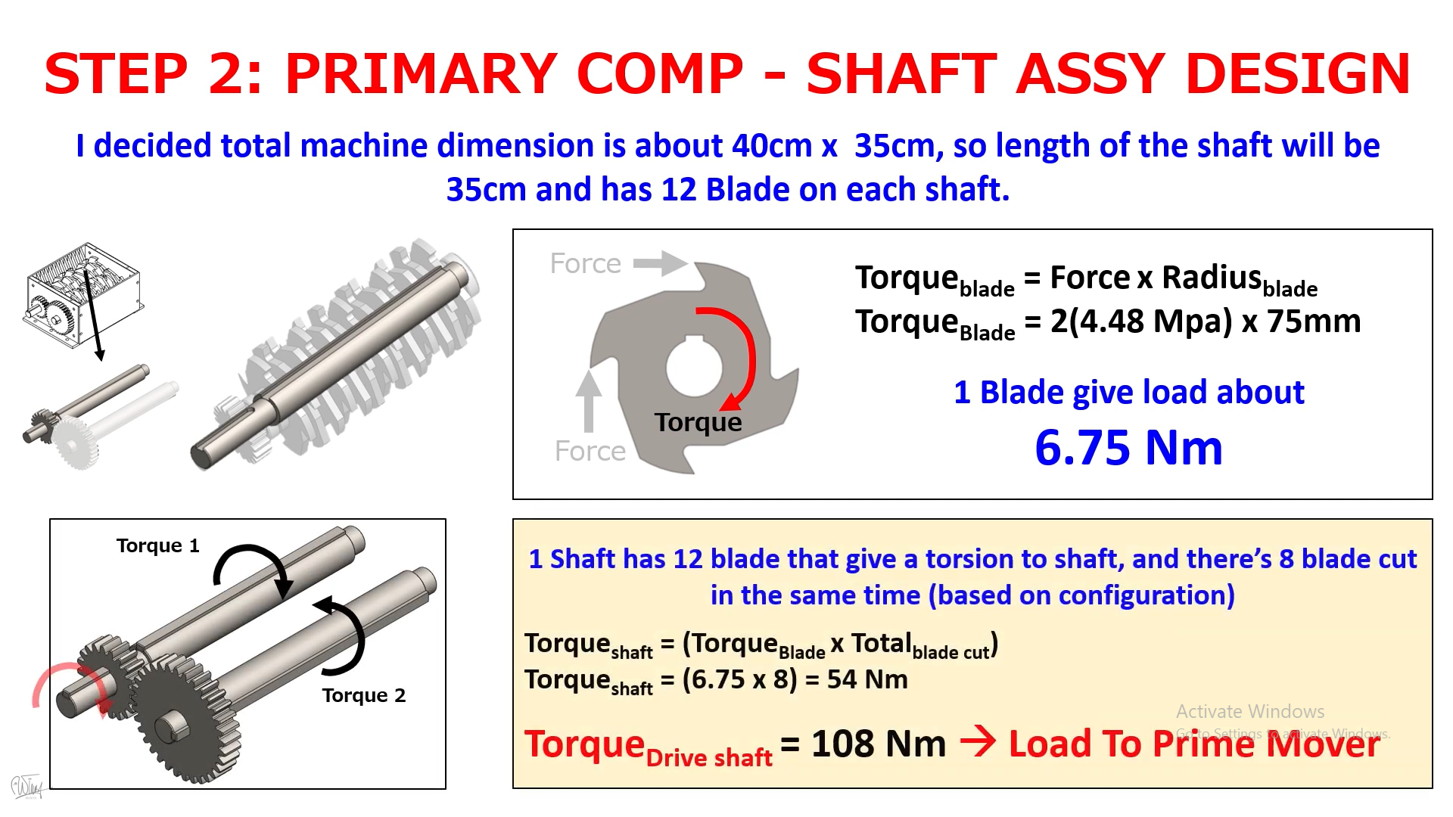

Figure ‎3.4. Torque generated by one blade.

$T_{blade}=2×F×r_{blade}$ (3.3)

Where:

$T_{blade}$: is the torque applied by one blade (Nm).

$r_{blade}$: is the radius of a single blade from its center to its knife (75 mm).

Thus:

$$T_{blade}=2×40×75 mm×{10}^{-3}= 6 Nm$$

Fourth, the blades’ material to avoid failure is chosen to be alloy steel since it has a high strength despite of its light weight

#### Shafts:

First, for a medium sized machine whose dimensions are chosen to be about 40 cm x 35 cm, the length of the shaft is chosen to be 35 cm.

Second, each shaft is designed to have 12 blades attached to it, with each blade generating torsion to the shaft, and there are 8 blades cutting at the same time according to the design configuration. So, the torque per shaft (as shown in Figure ‎3.4) can be calculated using the following equation:

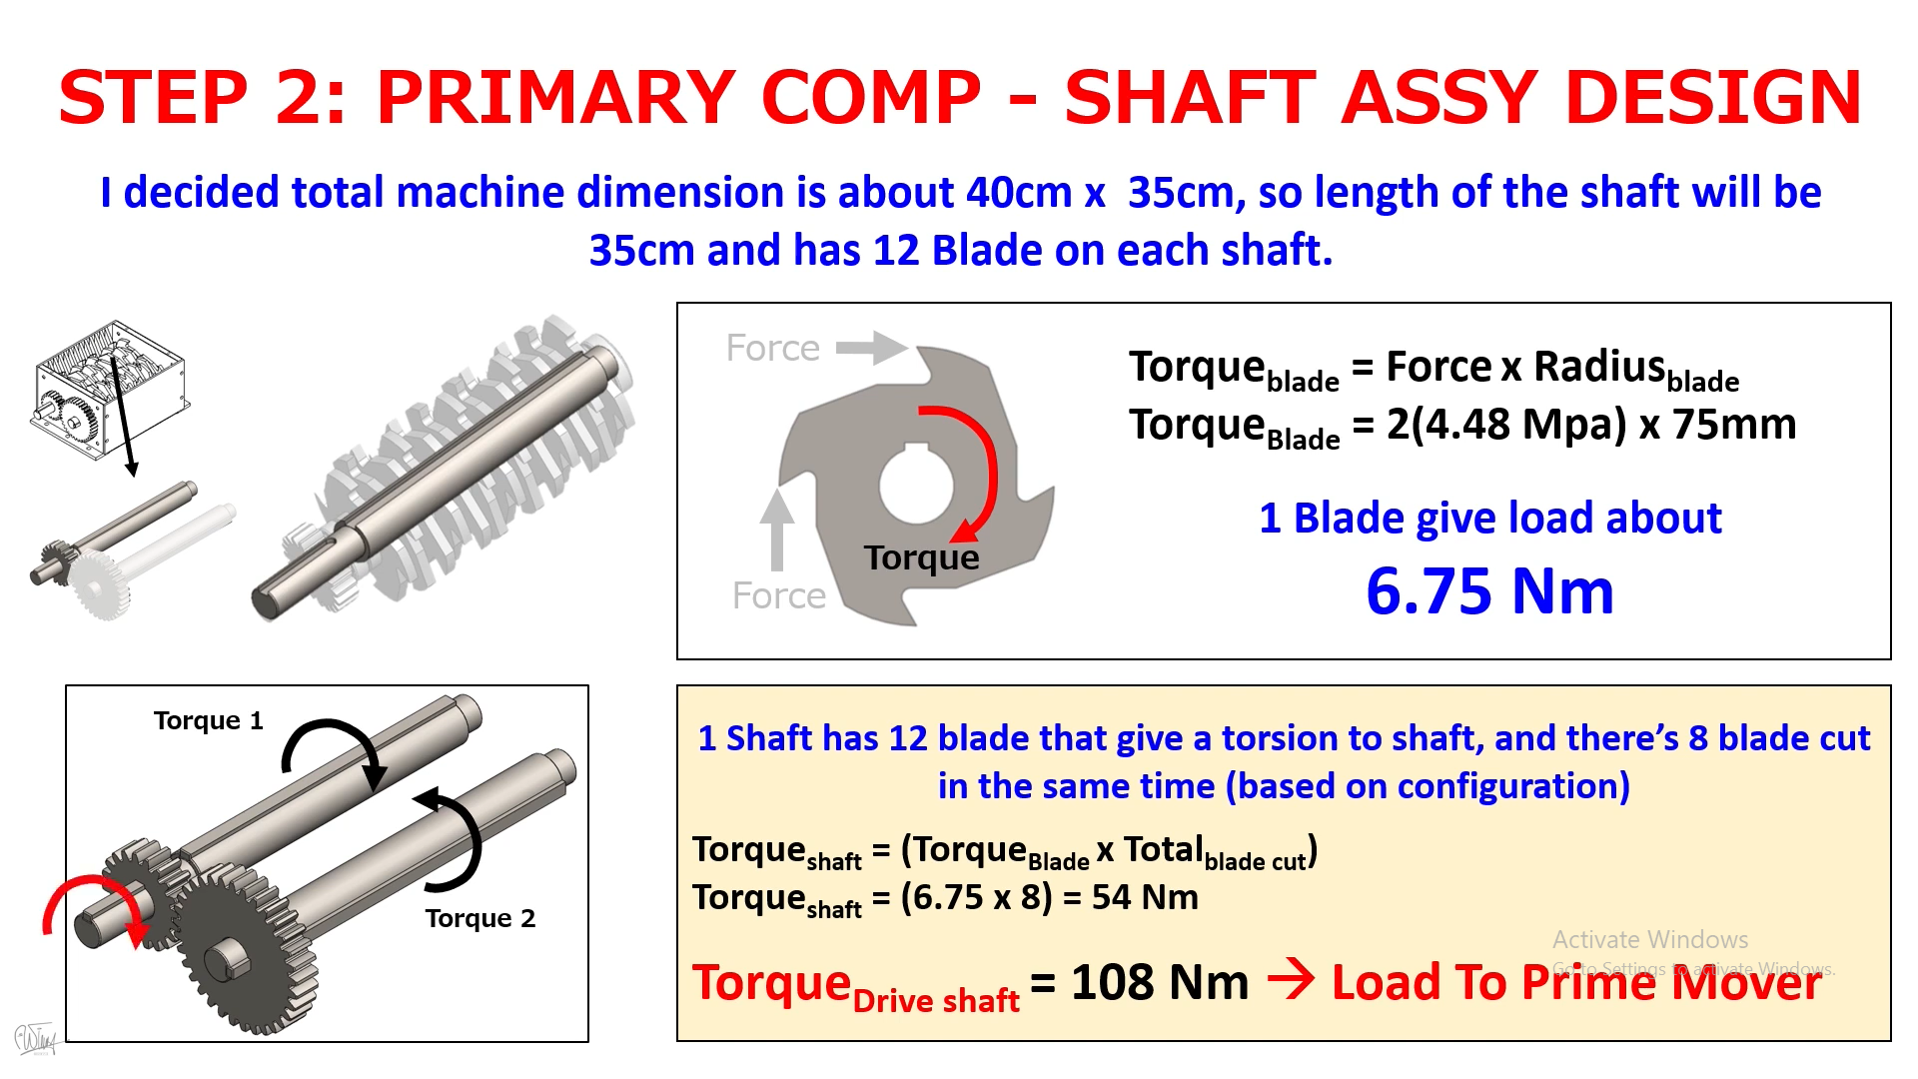

Figure ‎3.5. Torques generated by the blades on the shafts.

$T_{ shaft}=T_{blade}×{Total}_{blade cut}$ (3.4)

Where:

$T_{shaft}$: is the torque applied on a single shaft (Nm).

${Total}_{blade cut}$: is the total number of blades cutting at the same time on one shaft.

Thus:

$$T_{shaft}=6×8=48 Nm$$

Third, there are 2 shafts, the driving shaft and the driven shaft, so the total torque required for the shafts to operate is shown in Figure ‎3.4, and can be calculated using equation 3.5.

$T_{total}=2×T_{ shaft}$ (3.5)

Where:

$T_{total}$: is the total torque (Nm).

Thus:

$$T_{total}=2×48=96 Nm$$

Fourth, the diameter of each shaft will be 40 mm consequently for the blades to be well fit with the shafts.

Fifth, the shafts’ material to avoid failure is chosen to be medium carbon steel since it has a high strength.

As we found the total torque for the machine to perform, the next step is to choose the motor specifications that play the main role of the prime mover part which can be sectioned into the following parameter calculation fragments.

## 3.3.2. Prime mover

Prime mover is the element that supplies power needed to run the process of the machine. This power is affected by many factors including the torque and the angular velocity. It will be calculated in the coming section.

#### 3.3.2.1. Driving angular velocity

The angular velocity of the driving shaft to work on a standard low angular speed (57 rpm for the driving shaft) is calculated using equation 3.6. Note that this speed can be anticipated according to the machine’s dimensions, the blade design, the power, and the torque.

$W_{driving shaft}= \frac{2×π}{60}×N$ (3.6)

Where:

$W_{driving shaft}$: is the angular velocity of the driving shaft (rad/s).

$N$: is the revolution per minute of the driving shaft (rpm).

Thus:

$$W_{driving shaft}= \frac{2×π}{60}×57=5.969 rad/s$$

#### 3.3.2.2. Power

First, the required power for the shafts (Figure ‎3.5), is calculated using equation 3.7.

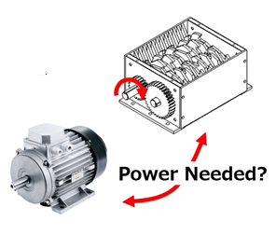

Figure ‎3.6. Power supplied from the motor to the shredding chamber.

$P=T_{total}×W_{driving shaft}$ (3.7)

Where:

$P$: is the desired power for the shredding system (W).

Thus:

$$P=96×5.969=573.026 W$$

Second, due to both mechanical and electrical losses in the system such as mechanical friction and copper losses, the power efficiency is represented by the following equation. Needless to say, these losses can’t be calculated unless we study the friction in the system. Hence, we will assume the efficiency of the system to be 80%.

$η=\frac{P}{P_{in}}×100=\frac{P}{P+P_{mech}+P_{elec}}×100$ (3.8)

Where:

$η$: is the power efficiency (80%).

$P_{in}$: is the input power supplied by the motor (W).

$P_{mech}$: is the mechanical loss (W).

$P_{elec}$: is the electrical loss (W).

Third, the required input power supplied by the motor will be calculated accordingly in the following equation.

$P_{in}=\frac{p}{η}$ (3.9)

Thus:

$$P_{in}=\frac{573.026}{0.8}=716.283 W÷746\frac{HP}{W}=0.96 HP≈1 HP$$

According to the input power, which came to be approximately 1 HP, we did a research on single phase motors to choose the most suitable one in such way that has a low rpm and a high torque which are demanded for our shredding machine. Therefore, we came to pick a motor that has 1 HP, 208-230 volt, 60 Hz, single phase, 56C frame, footed C-Face, 3.44 FL Amps and 1200 RPM. This motor is shown in Figure ‎3.6.

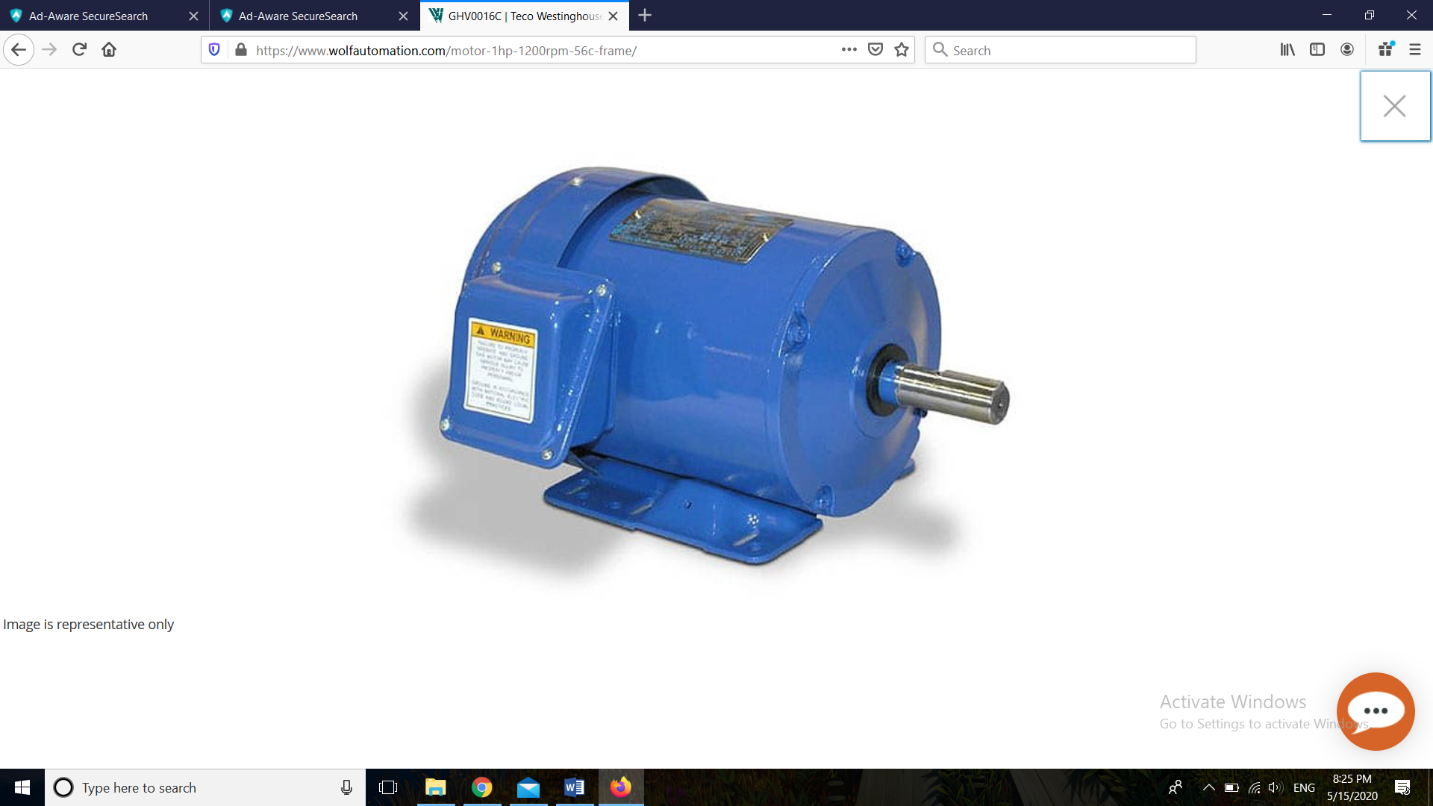

Figure ‎3.7. Selected motor [26].

## 3.3.2. Tnasmission

Transmission is actually the mechanism that stands beyond transmitting power to the shredding box. This power is mainly transmitted via three rpm reduction components; Pulleys, belts, and gears.

#### 3.3.2.1. The gearbox

The motor is intentionally selected to have a gearbox that is already installed in it. The gearbox will act as a reducer to decrease the rotational speed from 1200 rpm (initial value) to 171 rpm with a gear ratio of 7.

The process of reducing the initial speed needs some calculations, mainly in order to select appropriate gears and check for interference between meshing gears. However; we will not state them in our paper because it is out of our scope.

#### 3.3.2.2. Pulley and belt systems

Since the desired speed is needed to be 57 rpm for our design machine to work, it is mandatory to reduce the resulted speed (171 rpm). However; this time we will rely on the pulley and belt system since it is: more economical, easier to maintain, and safer for the motor in case of an overload.

First, we will choose the pulley and belt system. There are three types of belt sizes: 3V, 5V, and 8V, each is used according to the power factor and the motor speed.

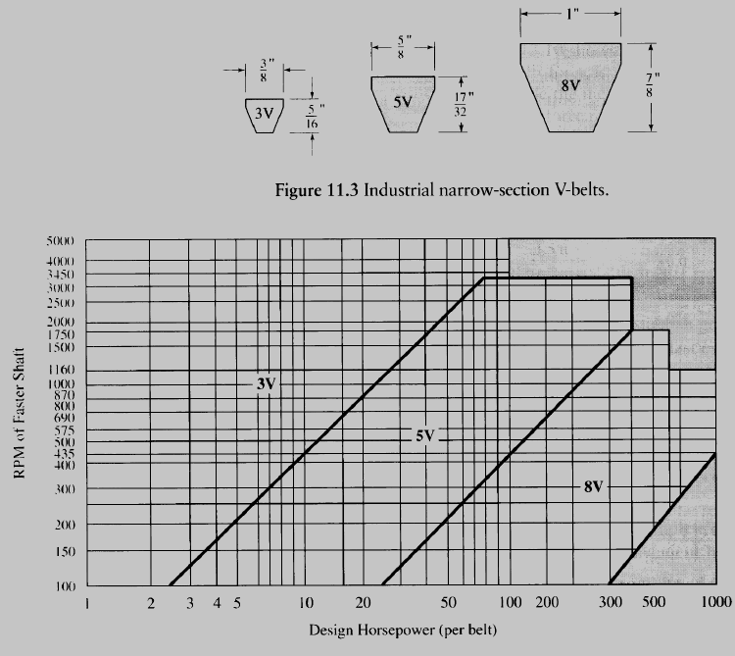

Figure 3.8. Industrial V-Belt selection chart.

Consequently, Using with 1 HP and 1200 motor driving speed, the 3V region is selected (referring to Figure 3.8). However, this region is constricted somehow so we switched to the 8V region as it is more flexible and has a bigger size range.

Next, the angular velocities of the driving pulley and the driven pulley are calculated using the following equation:

$W=2×π×N$ (‎3.10)

Where:

$W$: is the angluar velocity of either driving pulley or the driven one (rad/min).

Thus:

$$W_{driving pulley}= 2×π×200=1256.637 rad/min$$

$$W_{driven pulley}= 2×π×57=358.141 rad/min$$

Keep in mind that a belt transfers an average power at speeds of 1000 to 2000 fpm (ft /min) [27]. Therefore, it is best to design a belt drive to operate in this range. Nonetheless, we aim to choose a belt speed of 1000 fpm. Accordingly, the diameter of the driving pulley will be selected using the equation ‎3.11.

$d_{1 }=2×\frac{V_{b }}{W_{driving pulley }}$ (‎3.11)

Where:

$d_{1 }$: is the diameter of the driving pulley (in).

$V_{b }$: is the speed of the belt (1000 fpm).

Thus:

$$d_{1 }=2×\frac{1000}{1256.637}=1.591 ft×12\frac{in}{ft}=19.098 in$$

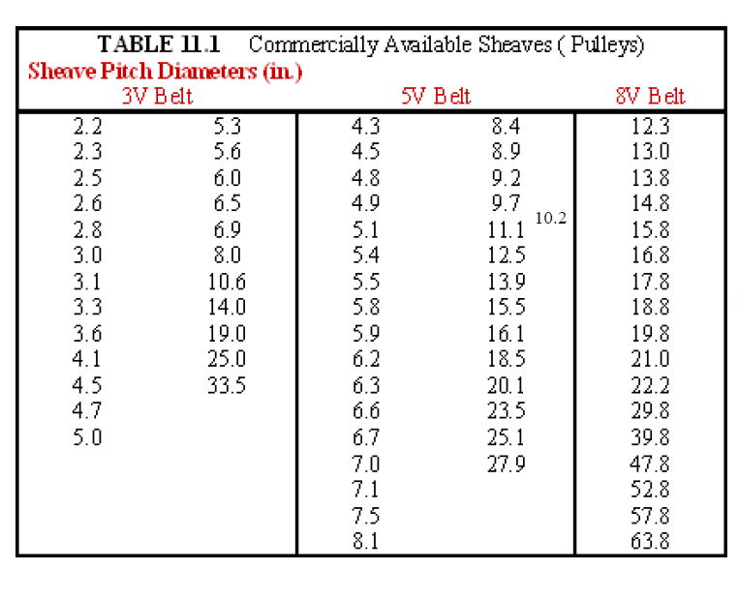

Figure 3.9. Commercially available pulleys (in).

Referring to Figure 3.9 the selected diameter of the driving pulley in the 8V region is 18.8 in, it is the closest available size in the market to our calculated one.

Next, knowing that the diameter of the driving pulley is 18.8 in, the actual belt speed will be calculated according to the following equation:

$V_{b}=\frac{d_{1}}{2}×W_{driving pulley }$ (‎3.12)

Where:

$V_{b }$: is the actual belt speed (fpm).

Thus:

$$V_{b }=\frac{18.8}{2}×1256.637=11812.387\frac{in}{m}÷12\frac{in}{ft}=984.365 fpm$$

Now, the desired velocity ratio is determined by the following equation:

$VR=\frac{W_{driving pulley }}{W_{driven pulley } }$ (‎3.13)

Where:

$VR$: is the velocity ratio of the pulley and belt system.

Thus:

$$VR=\frac{1256.637}{358.141 }=3.5$$

Therefore, the diameter of the driven pulley is calculated by:

$d_{2}=VR×d_{1}$ (‎3.14)

$d_{2}$: is the diameter of the driven pulley (in).

Thus:

$$d_{2}=3.5×18.8=65.8 in$$

Similarly, referring to the table… the closest available size in the 8V region will be 63.8 in. Afterwards, the actual angular velocity of the driven pulley will be calculated using the following formula:

$W_{driven pulley}=W_{driving pulley}×\frac{d_{1}}{d_{2}}$ (‎3.15)

Thus:

$$W_{driven pulley}=1256.637×\frac{18.8}{63.8}=370.294\frac{rad}{min}÷2π≈59rpm$$

Now, using equation ‎3.13, the VR is recalculated to deduct its actual value that happens to be equal to 3.4.

Finally, we need to select the suitable belt for our system according to the following equations:

$d_{2}<C<3×\left(d_{2}+d_{1}\right)$ (‎3.16)

Where:

$C$: is the center to center distance of the first system (in).

Thus:

$$18.8<C<3×\left(63.8+18.8\right)$$

Yielding:

$$18.8 in<C<247.8 in$$

A value of 133.3 in from the above range is timidly selected.

For the belt length:

$L=2×C+\frac{π}{2}×\left(d_{2}+d_{1}\right)+\frac{{(d_{2}-d_{1})}^{2}}{4×C}$ (‎3.17)

Where:

$L$: is the belt length (in).

Thus:

$$L=2×133.3+\frac{π}{2}×\left(63.8+18.8\right)+\frac{{(63.8-18.8)}^{2}}{4×133.3}$$

Yielding:

$$L=400.145 in$$

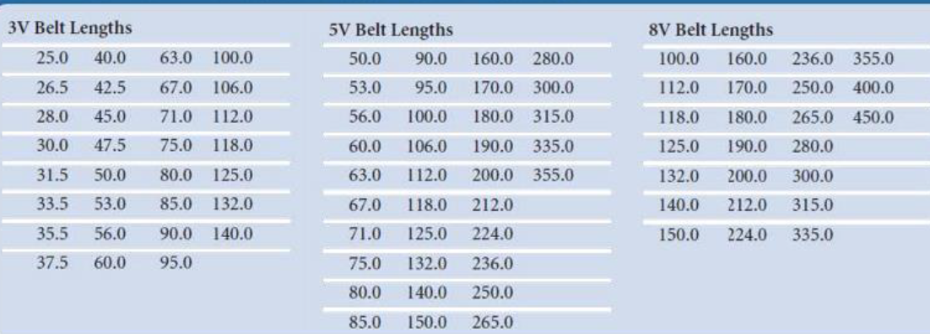

Figure 3.10. Commercially available V-Belt length (in).

Analogously, referring to Figure 3.10 the closest available length in the 8V region will be 400 in. Thus, the belt length (L) is equal to 400 in.   
Now, to calculate the actual $C$, the required parameter $B$ is calculated using the following equation:

$B=4×L-2×π×\left(d_{2}+d_{1}\right)$ (‎3.18)

Where:

$B$: is the correction factor (in).

$L$: is the available length of the belt (400 in).

Thus:

$$B_{1}=4×300-2×π×(47.8+13.8)$$

Yielding:

$$B_{1}=1081 in$$

Therefore, the actual center to center distance is calculated by:

$C=\frac{B+\sqrt{B^{2}-32×{(d_{2}-d_{1})}^{2}}}{16}$ (‎3.19)

Thus:

$$C=\frac{812.955+\sqrt{{812.955}^{2}-32×{(47.8-13.8)}^{2}}}{16}$$

Yielding:

$$18.8 in<C=133.226 in<247.8 in$$

To avoid failure and belt slipping, we will use a Grey Cast Iron (GCI20) because they are less corrosive and has a high inertia due to its weight. In addition, the belt material will be Fabric Rubber since its number of layers increase its strength and the friction coefficient.

#### 3.3.2.3. Gears

For the final step, we will use 1:1 gears to transmit power from the driving shaft to the driven one. There exist several types of gears in the market, each is manufactured for a specific use or purpose. There are spur gears, helical gears, rack and pinion, bevel gears, miter gears, worm and worm gears, screw gears, and lastly internal gears.

For our design we will use the spur gears (as shown in Figure 3.11 ) since they have high power transmission efficiency, they are compact and easy to install, they also offer a constant velocity ratio and unlike belt drives, spur gears drive to have no slip. Thus they are highly reliable and suitable for our design machine.

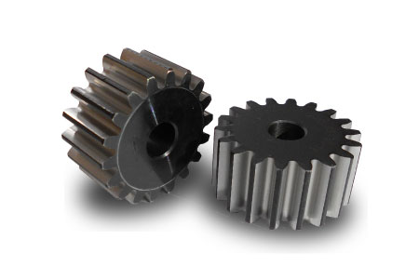

Figure 3.11. Spur Gears [28].

The process of transmitting power from the motor to the pulley and belt system through to the shafts, needs some calculations. However; we will not go through them in our paper because it is out of our scope because gears have numerous parameters needed to be computed such as the circular pitch, the chordal pitch, and the pitch surface in addition to the face width, the bottomland, the fillet and much more (see Figure 3.12).

Finally both shafts will operate at a constant speed of 59 rpm transmitted through the 1:1 spur gears. Therefore, our machine will operate safely and properly following the calculation steps mentioned previously. The gear material will be selected to be an alloy steel.

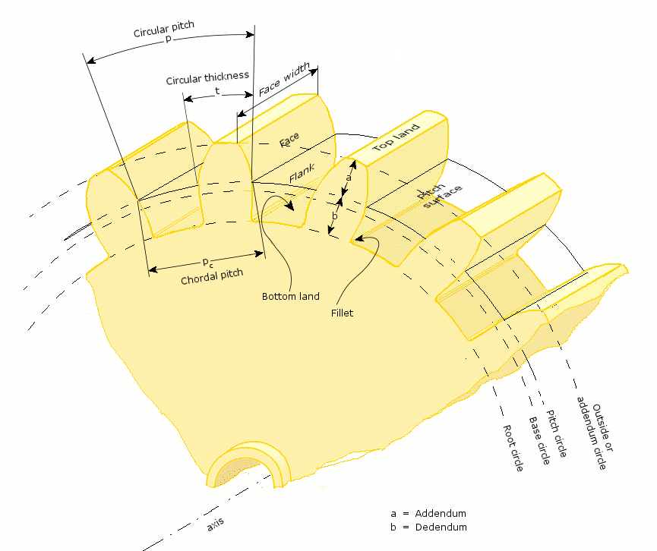

Figure 3.12. Spur gears configuration parameters [28].

## Conclusion

As we said earlier in the paper, recycling process needs to be done on several stages. Each stage elaborates a different treatment (see section 2.5). It is so credible to divide the recycling process since it is a long cycle and requires numerous fields to work on. Thus, for our project, we selected the shredding stage, as it mainly requests for mechanical specialists to get the work done. After calculating and testing, we can be sure that our design is feasible and can be manufactured ignoring the calculation of other parameters such as friction, power losses, actual efficiency of the system, etc.

Our design is desired to be placed on public places, so it is highly recommended to deliver the project to other fields which can add an external design box that can be fit with the surrounding and a rewarding system that encourages people to get the shredding work done.

# Prototype construction

## Intoduction

A prototype is an early sample, model, or release of a product or a machine built to test a concept or a process [29]. A prototype is generally used to evaluate a new design to enhance precision.

Our prototype will be mostly represented on SolidWorks software. Knowing that the greatest essential part of our machine, as we stated earlier, is the shredding box, we narrowed our efforts and focused on doing the shredding box that shows the shredding mechanism that will transform the PET bottle into small particles that may be treated later by different processes like pelletizing.

## Prototype components

We first drew the blades with certain dimensions (mentioned previously in the paper). We had drew three blades with different key orientation. One has zero degree (as in Figure 4.1), another has 120 degrees (as in Figure 4.2), and the last has 240 degrees (as in Figure 4.3).

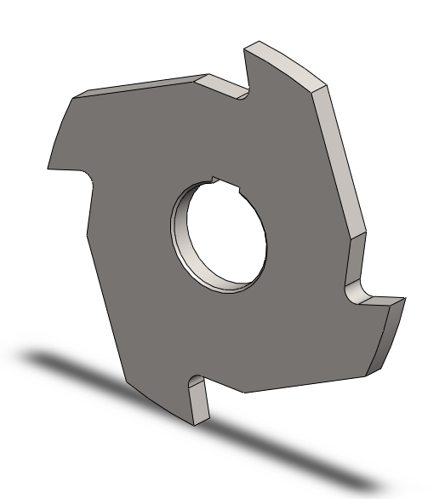

Figure 4.1. Zero-degree blade.

Needless to say that the orientation of the key changes the orientation of the blade’s knife as well when located on the shaft.

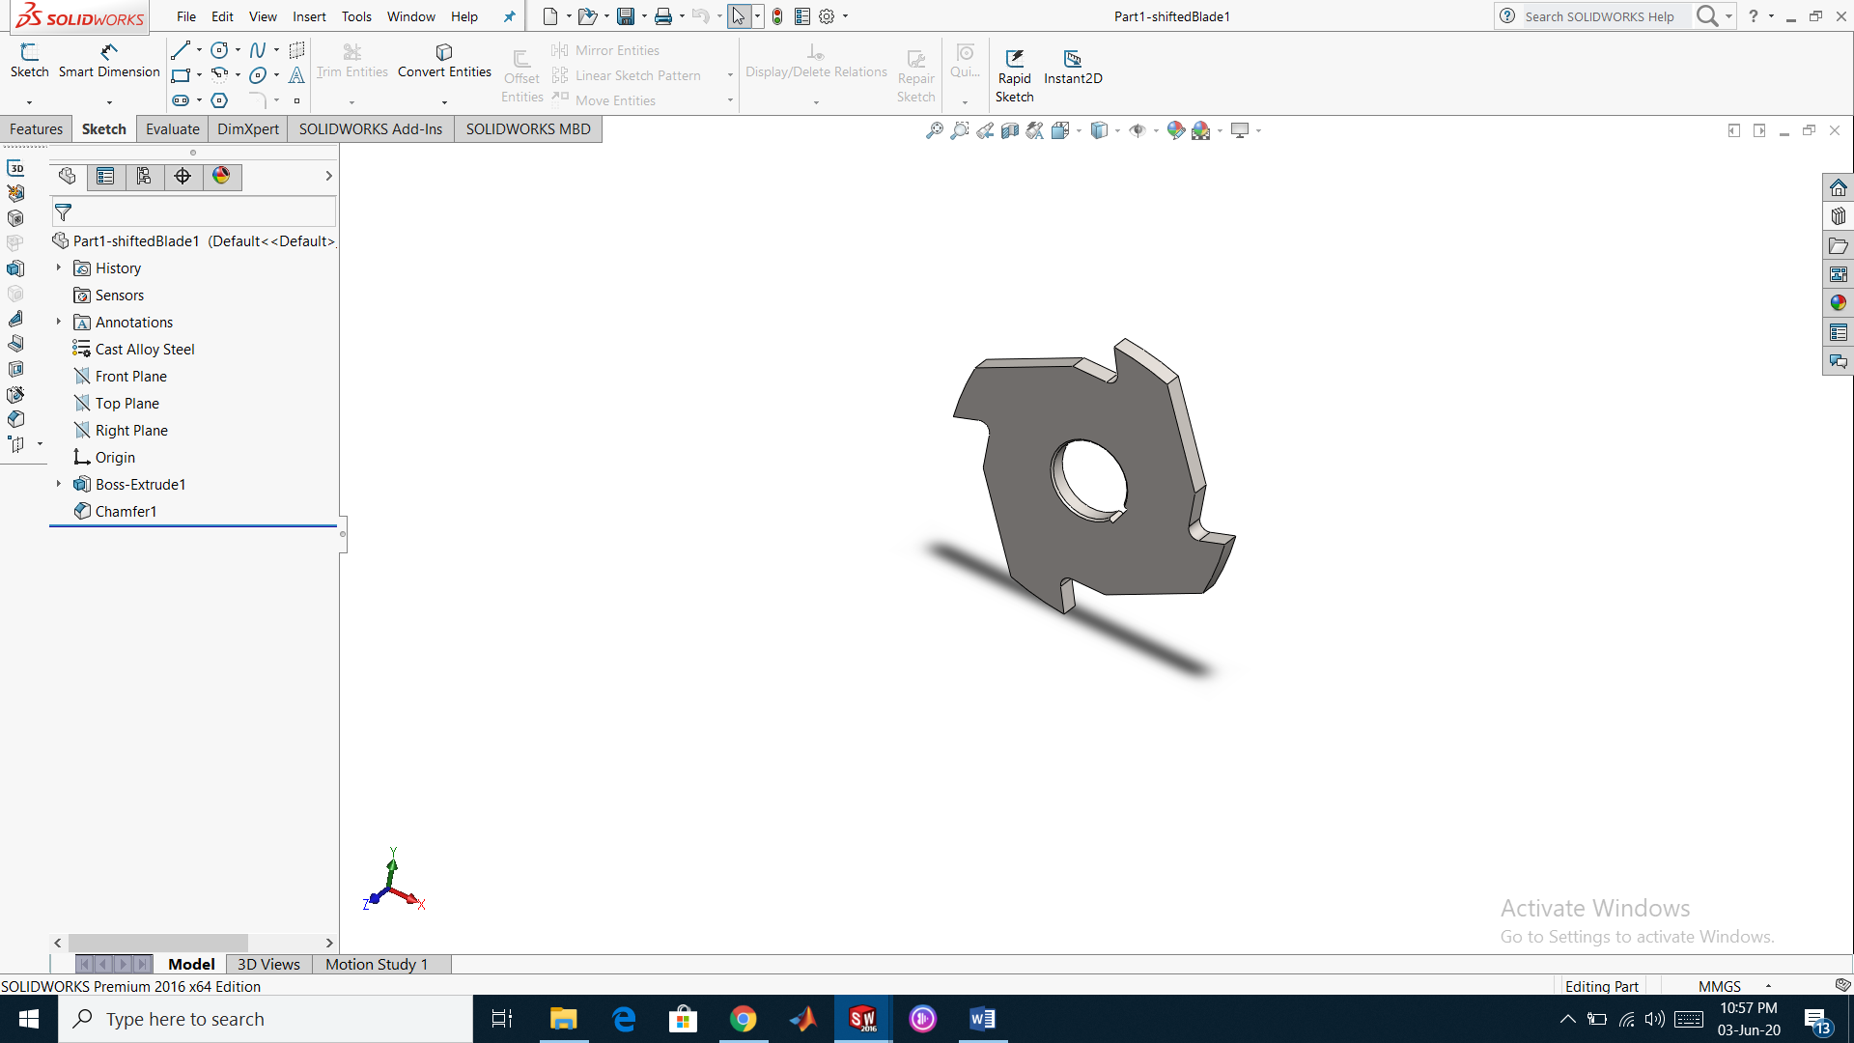

Figure 4.2. 120-Degree blade.

This would definitely enhance the cutting process of the PET plastic bottles. The bottle would be subjected to the cutting force of the blade sequence at different instances.

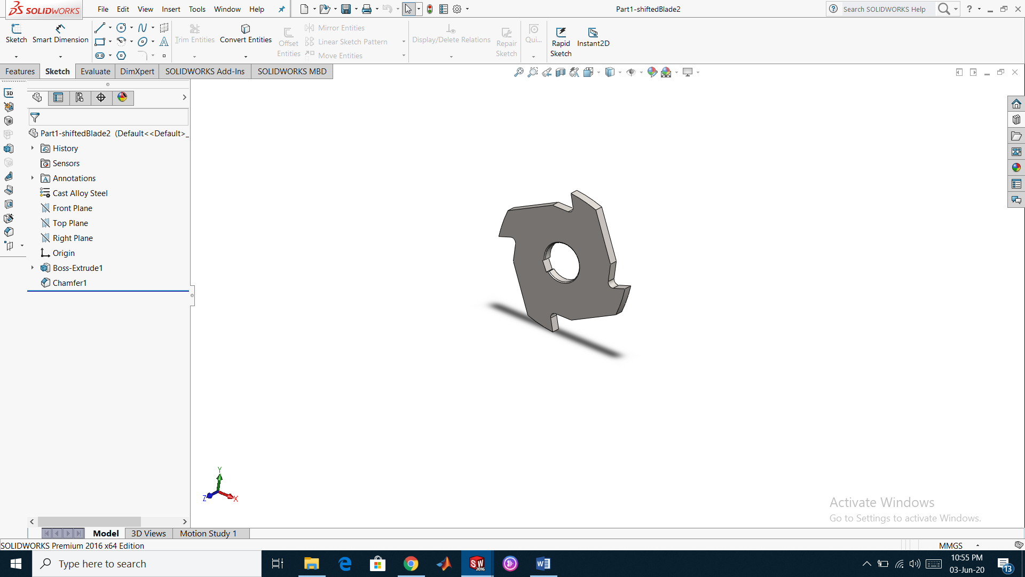

Figure 4.3. 240-Degree blade.

Right after finishing the blades, we jumped to draw the shaft (see Figure 4.4) which is usually a circular-rotating machine element. It will be used to transmit power from the motor (prime mover) to the blades through both a pulley-belt system and a set of gears [28].

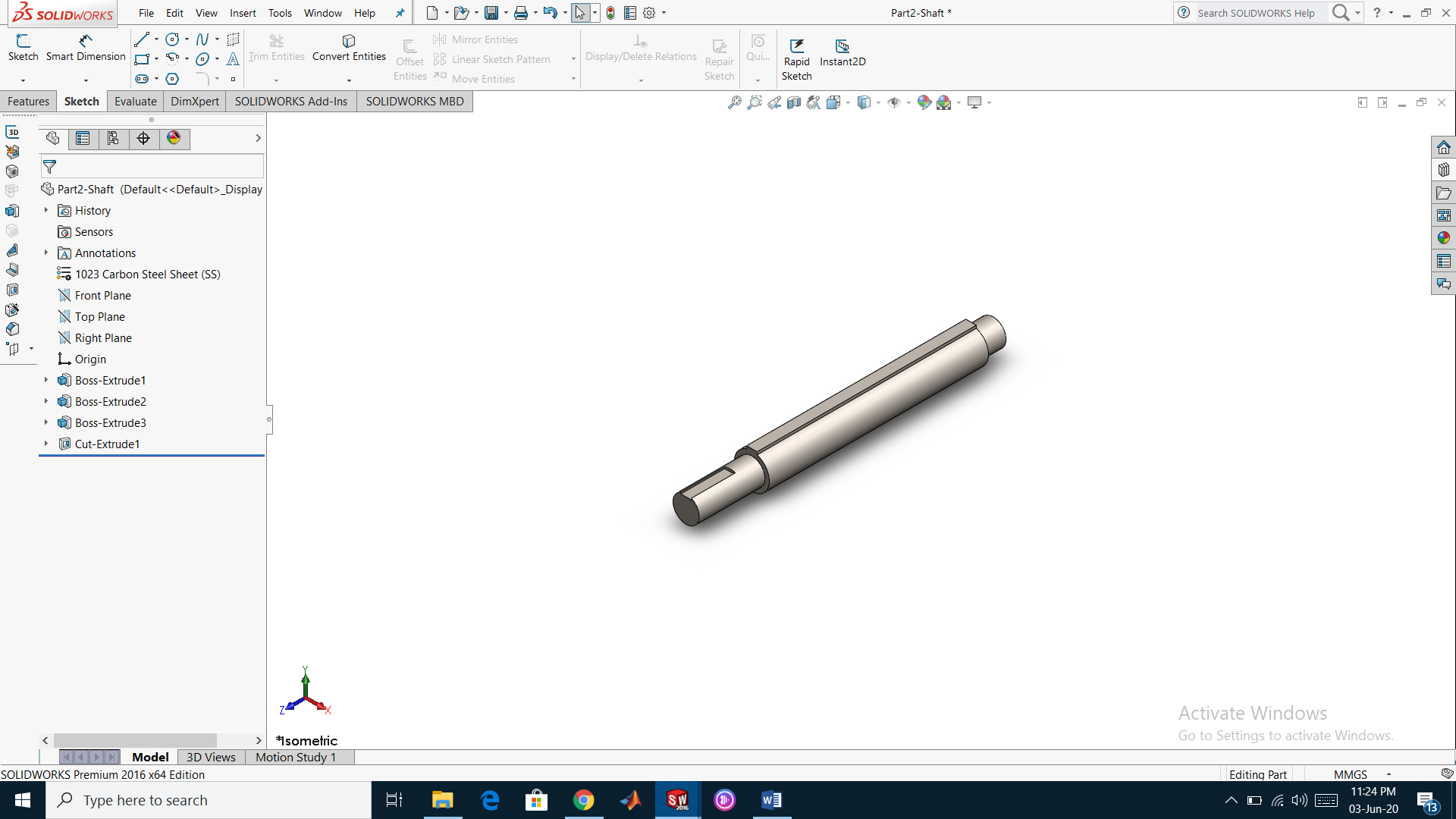

Figure 4.4. The shaft.

Our machine system will has two identical shafts of length 35 cm. they are designed of this specific length just to fit with the machine frame. The shaft has three main components; the body, along with a fixed key, the right fragment, and the left one.

The shaft’s body is designed to hold 12 blades (each has a thickness of 10 mm) and 13 bearings (each has a thickness of 10 mm), thus its length would be 25 cm leaving a space of 10 cm that will be divided unequally on the sides; 25 mm for the right side and 75 for the left side. The left side is intentionally chosen to be longer because we need to place a set of gears from this side to transmit power to the blades.

Then we drew the bearing (installed between the blades), the outside bearing, (that will be holding the walls of the shredding box), the key (that closes the system after the installation of the outside bearing), the gears, and finally the box (each side of the box is drawn separately).

Finally, all the mentioned parts were combined together to form the assembly that is shown in Figure 4.5.

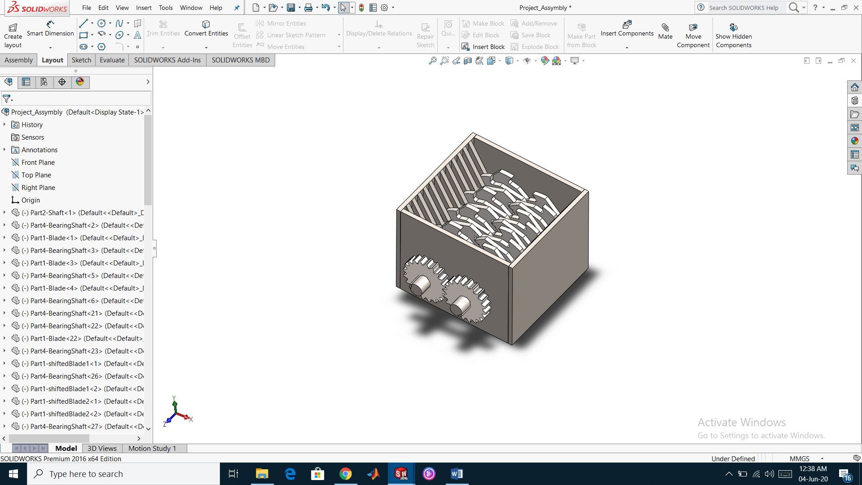

Figure 4.5. Project assembly.

## Conclusion

To conclude, in what we said previously our project is consisted from different part as illustrated before. We mentioned before the relation between these components and how they work. Furthermore, we made a simple simulation on solid works software to show how our system will perform.

# Overall conculsion

As a final point, perceiving the pollution dilemma and finding a way to reduce its brute effects on all living creatures has been our concern from the very beginning. And as an answer to this problem, we have assigned ourselves to prudently design a small sized plastic recycling machine. Consequently, a process that allows us to achieve our goal has been planned. Initially, we started by introducing the problem and its aspects, then we did a research about the origin of plastics and the human use of it. Afterwards, we introduced the multiple types of machines used in the process of plastic recycling in the market. Then most importantly, from the big picture, we narrowed our ideas and thoughts to select a specific area of study in this process, which came to be the shredding one. Thereafter, we proceeded to both design and simulate our machine through applying our knowledge in it. Consequently, to enhance our shredding mechanism and to reduce the errors, a study about the full aspects of our machine is crucially desired; For instance, the friction factor could be introduced and studied in the calculation part. Moreover, numerous design factors that certainly affect the efficiency could be studied, such as: the number of blades and shafts, the geometry of the blade, the gears’ parameters, and the distance between the rotating shafts. Additionally, we couldn’t proceed with the heat treatment process, since calculations are more complex, and the enormous sized combustion chamber demands high insulation.

However, we can enhance the way of using this machine, as said before, the rewarding system is a prominent idea to encourage humans to recycle plastics, since this machine could be placed in public places.

To close, we expect to have obtained our important aim, that is, to arouse to the environmental significance of recycling. Before we throw something, let’s think of reusing it first. We learned through our paper that recycling plastics is not that easy. It poses some real challenges, however; recycling has a low cost regarding its benefits.

# References

|  |  |
| --- | --- |
| [1] | [Online]. Available: https://www.numbeo.com/pollution/rankings_by_country.jsp?title=2019. |
| [2] | [Online]. Available: https://www.environmentalpollutioncenters.org/soil/diseases. |
| [3] | [Online]. Available: https://www.greenandgrowing.org/consequences-of-water-pollution. |
| [4] | [Online]. Available: https://www.arabnews.com/node/1202376/middle-east. |
| [5] | [Online]. Available: https://en.wikipedia.org/wiki/Control_of_fire_by_early_human. |
| [6] | [Online]. Available: https://www.filmsupply.com/collections/caveman-makes-fire/2280. |
| [7] | [Online]. Available: https://interestingengineering.com/19-great-inventions-that-revolutionized-history. |
| [8] | [Online]. Available: https://www.aramcoworld.com/Articles/July-2017/Why-Reinvent-the-Wheel. |
| [9] | [Online]. Available: https://www.sciencehistory.org/the-history-and-future-of-plastics. |
| [10] | [Online]. Available: https://www.history.com/topics/industrial-revolution/industrial-revolution. |
| [11] | [Online]. Available: https://www.sciencehistory.org/the-history-and-future-of-plastics. |
| [12] | [Online]. Available: https://www.chinadailyhk.com/articles/84/154/8/1560409023489.html. |
| [13] | [Online]. Available: https://www.sciencelearn.org.nz/resources/2809-how-harmful-are-microplastics. |
| [14] | [Online]. Available: https://www.sciencedirect.com/science/article/pii/S187802961630158X. |
| [15] | [Online]. Available: https://www.thoughtco.com/recycling-plastics-820356. |
| [16] | [Online]. Available: https://www.ncbi.nlm.nih.gov/pmc/articles/PMC2873020/. |
| [17] | [Online]. Available: https://www.weforum.org/agenda/2019/12/black-plastic-recycling-supermarkets-waste/. |
| [18] | [Online]. Available: https://www.polytecpm.com/products/?gclid=CjwKCAjwsMzzBRACEiwAx4lLGzBbjhAZ-OZlOqIOph8IFG3L_rW-wpwEYXoPpCgmoXwkPae8odzkAhoCiocQAvD_BwE.. |
| [19] | [Online]. Available: https://www.plastrecycle.com/products/plastic-washing-machine/pet-bottle-regrindingwashing-recycling-line/?gclid=EAIaIQobChMIg_Guls7v6AIVg-3tCh2LgwubEAAYASAAEgIVCPD_BwE. |
| [20] | [Online]. Available: https://www.gepecotech.com/shredder/ge.html?gclid=EAIaIQobChMIkpKuztjv6AIVCevtCh1Qzgh4EAAYASAAEgIWN_D_BwE. |
| [21] | [Online]. Available: https://www.prm-taiwan.com/F0003/S1851/product_i_Recycled_Pelletizing_Machine_(JC-ECOTRIM_Series).html. |
| [22] | [Online]. Available: https://crigler.com/shredding-for-newbies-different-types-of-shredder-systems/. |
| [23] | R. L. Norton, Design of Machinery, McGraw-Hill, 2003. |
| [24] | [Online]. Available: https://www.rsisinternational.org/virtual-library/papers/development-of-dual-shaft-multi-blade-waste-plastic-shredder/. |
| [25] | R. C. HIBBELER, Mechanics of Materials, United States of America: Pearson Prentice Hall.. |
| [26] | [Online]. Available: https://www.wolfautomation.com/gh0016c-motor-1hp-1200rpm-56c-frame/. |
| [27] | J. H. Cromwell, Treastise On Belts And Pulleys, Nabu Press, 2011. |
| [28] | T. W. Barber, A Victorian Handbook of Mechanical Movements, Courier Corporation, 2013. |
| [29] | B. Hallgrimsson, Prototyping and Modelmaking for Product Design, Laurence King Publishing, 2012. |

##### Title of the App A

###### Level 2 in Appendix, Apply Heading 6

For the captions in Appendices, you **must** use copy-paste from the figures and tables below.

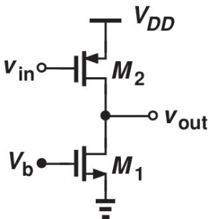

Figure A.1. First figure in appendix A.

Table A.1. First table in Appendix A

|  |  |  |  |  |
| --- | --- | --- | --- | --- |
| A-D | A | B | C | D |
| 1 | A1 | B1 | C1 | D1 |
| 2 | A2 | B2 | C2 | D2 |
| 3 | A3 | B3 | C3 | D3 |

Level 3 in Appendix, Apply Heading 7

Level 4 in Appendix, apply Heading 8

Equations in Appendix A

For the equations in Appendix, the best practice is to Copy-Paste-Edit the equation below then update it by selection the number and hitting F9 on your Keyboard, then Edit the equation.

$A=πr^{2}$ (A.1)

##### Title of the App B

###### Level 2 Section, Apply Heading 2

For the captions in Appendices, you **must** use copy-paste from the figures and tables below.



Figure B.1. First figure in appendix B.

Table B.1. First Table in Appendix B.

|  |  |  |  |  |
| --- | --- | --- | --- | --- |
| A-D | A | B | C | D |
| 1 | A1 | B1 | C1 | D1 |
| 2 | A2 | B2 | C2 | D2 |
| 3 | A3 | B3 | C3 | D3 |

###### For the References:

References must be entered in “REFERENCES” section before they are cited. The style is “references”. The template will number citations consecutively within brackets [1]. Refer simply to the reference number, as in [2]—do not use “Ref. [2]” or “reference [2]” except at the beginning of a sentence: “Reference [2] was the first ...”

Unless there are six authors or more give all authors’ names; do not use “et al.”. Papers that have not been published, even if they have been submitted for publication, should be cited as “unpublished” [3]. Papers that have been accepted for publication should be cited as “in press” [4]. Capitalize only the first word in a paper title, except for proper nouns and element symbols.

To Cite a New Reference

Insert 🡪Cross-reference 🡪 select: Reference Type= numbered item 🡪 select: Insert reference to: Paragraph number 🡪 in “For which numbered item”, scroll to your reference 🡪 select your reference 🡪 click Insert

Equations in Appendix B

For the equations in Appendix, the best practice is to Copy-Paste-Edit the equation below then update it by selection the number and hitting F9 on your Keyboard, then Edit the equation.

$A=πr^{2}$ (B.1)